TASK 12-

(A) MFA 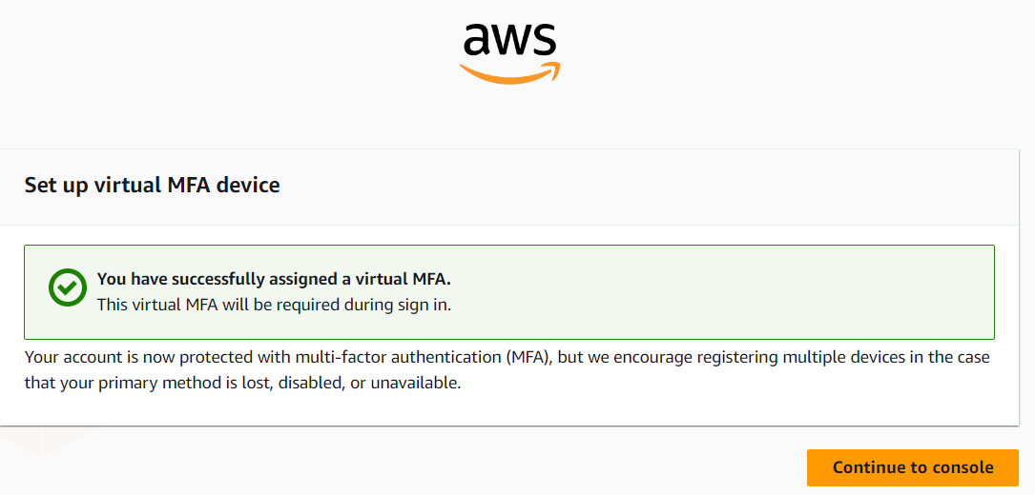

(B)Create a CDN using Amazon S3 and CloudFront

1.Creating and Configuring S3 Bucket

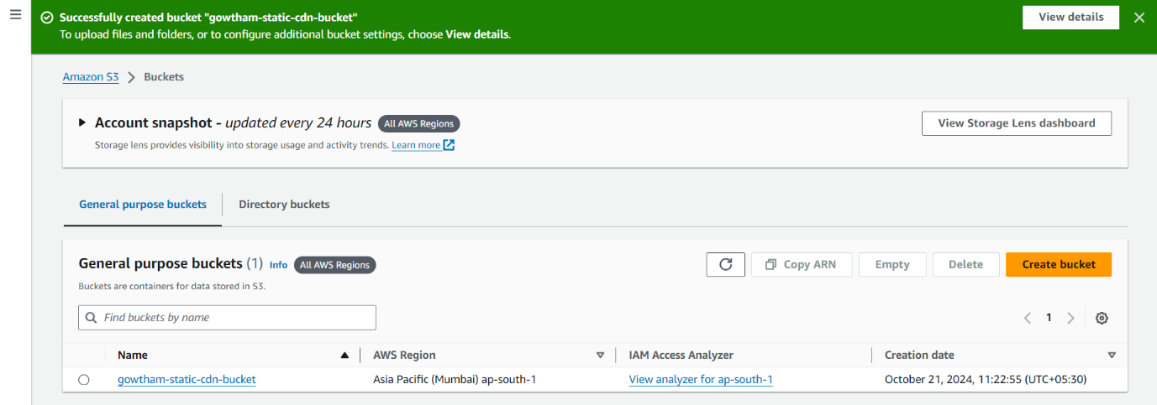

2.Uploading Static Content (HTML) to S3

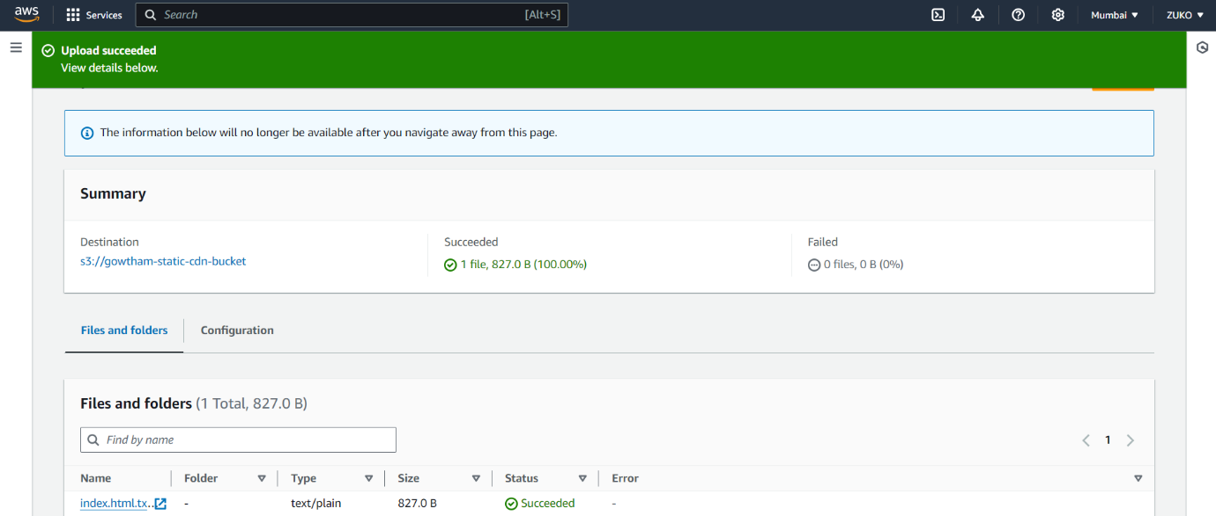

3.Enabling static web hosting

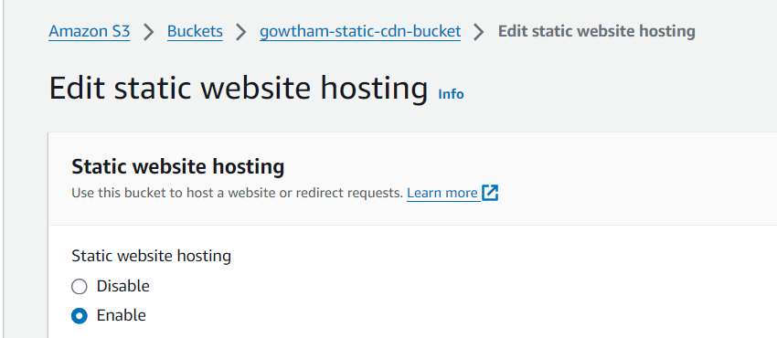

4.Setting Up CloudFront Distribution

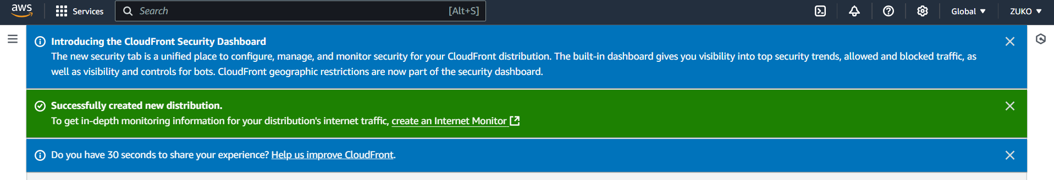

5.Testing and Accessing CloudFront Distribution

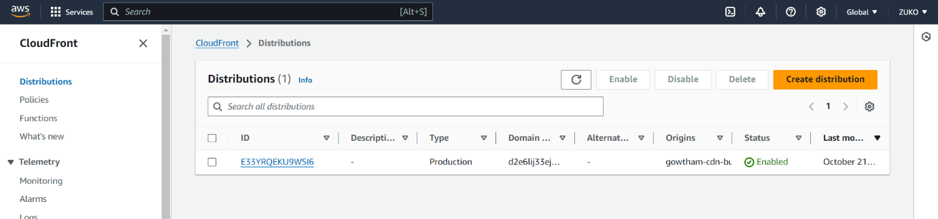

6.OUTPUT

